**Deep Learning Lab**

**Computer Vision Track  
Assignment 3 Report**

Kinan Alzouabi

WS 2018/2019

# Task

I have trained an Encoder-Decoder network with 4 different configurations of the decoder network. The encoder-decoder network is used for semantic segmentation. Moreover, we are studying the impact of the number of upsamples performed and the use of skip connections on the performance of the network. The configurations are described in the following table.

Table 1- configurations to be implemented

|  |  |  |
| --- | --- | --- |
| Number of upsamples | Upsampling rates | Configuration |
| One | 16x | 1 |
| Two | 2x -> 8x | 2 |
| Three | 2x -> 2x -> 4x | 3 |
| Four | 2x -> 2x -> 2x -> 2x | 4 |

# Network Architecture

## **Configuration 1**

There is no refinement block and we directly upsample the feature map from the encoder to the size of the image. So we have an upsampling layer that give an output feature map of size 120, upsampling rate of 16 and kernel size of 3x3. This layer is followed by a Conv layer with output feature map of a size equal to the Number of classes, upsampling rate of 1, and kernel size of 1x1.

## **Configuration 2**

There is one refinement block with one skip connection. This configuration is better described in table 2, and in figure 1.

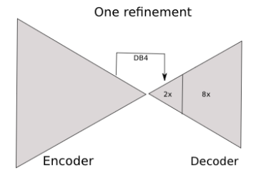

Figure 1- Configuration 2

Table 2- Configuration 2

|  |  |  |  |
| --- | --- | --- | --- |
| Layer number | Output feature maps | Upsampling rate | Kernel size |
| Upsample 1 | 256 | 2 | 3x3 |
| Conv 1 | 256 | 1 | 1x1 |
| Upsample 2 | 120 | 8 | 3x3 |
| Conv 2 | Number of classes | 1 | 1x1 |

## **Configuration 3**

There is two refinement blocks with two skip connections. This configuration is better described in table 3, and in figure 2.

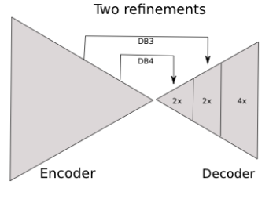

Figure 2- Configuration 3

Table 3- Configuration 3

|  |  |  |  |
| --- | --- | --- | --- |
| Layer number | Output feature maps | Upsampling rate | Kernel size |
| Upsample 1 | 256 | 2 | 3x3 |
| Conv 1 | 256 | 1 | 1x1 |
| Upsample 2 | 160 | 2 | 3x3 |
| Conv 2 | 160 | 1 | 1x1 |
| Upsample 3 | 120 | 4 | 3x3 |
| Conv 3 | Number of classes | 1 | 1x1 |

## **Configuration 4**

There is two refinement blocks with two skip connections. This configuration is better described in table 4, and in figure 3.

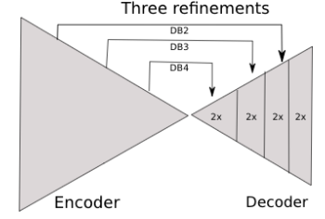

Figure 3- Configuration 4

Table 4- Configuration 4

|  |  |  |  |
| --- | --- | --- | --- |
| Layer number | Output feature maps | Upsampling rate | Kernel size |
| Upsample 1 | 256 | 2 | 3x3 |
| Conv 1 | 256 | 1 | 1x1 |
| Upsample 2 | 160 | 2 | 3x3 |
| Conv 2 | 160 | 1 | 1x1 |
| Upsample 3 | 96 | 2 | 3x3 |
| Conv 3 | 96 | 1 | 1x1 |
| Upsample 4 | 120 | 2 | 3x3 |
| Conv 4 | Number of classes | 1 | 1x1 |

# Results

Figure 4 is a plot of Intersection over Union (IoU) vs epochs for each decoder configuration. Moreover, table 5 is a table with maximum IoU value for each configuration.

Table 5- Maximum IoU value for each configuration

|  |  |
| --- | --- |
| Configuration | maximum IoU value |
| 1 | 0.0364831800209 |
| 2 | 0.0715420922407 |
| 3 | 0.162767471557 |
| 4 | 0.196933913661 |

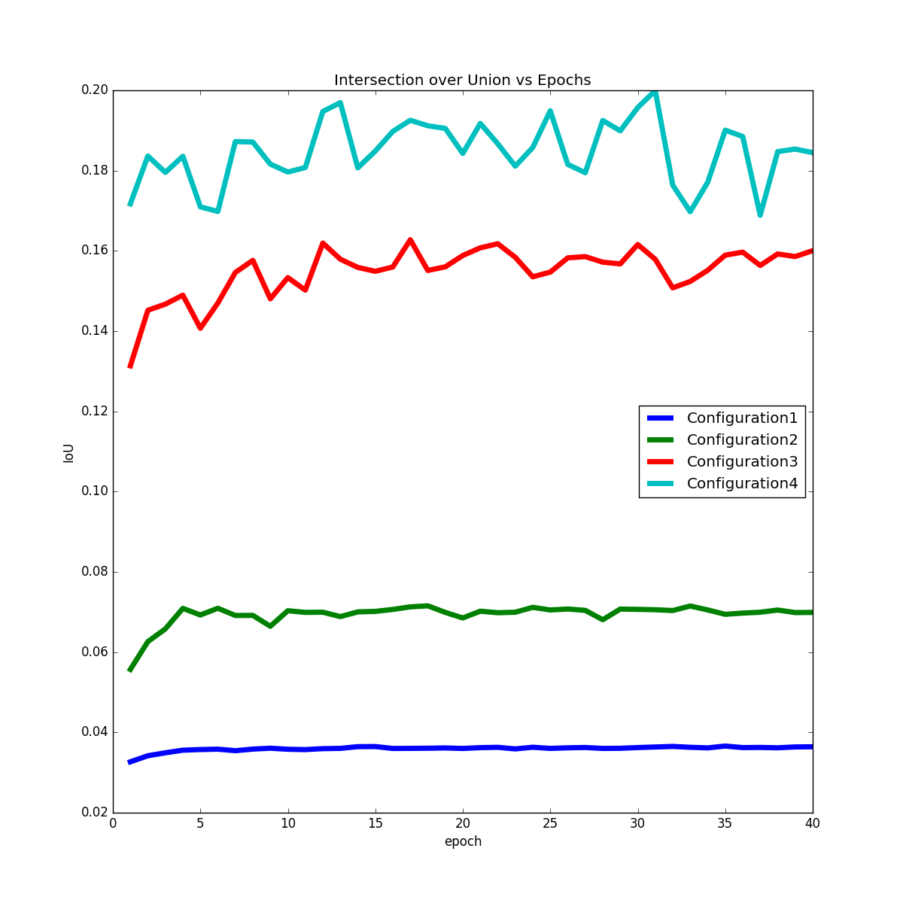

Figure 4- Intersection over Union (IoU) vs epochs for each decoder configuration